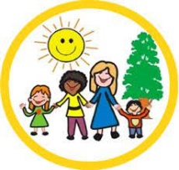
Dear Parents and carers
Through conversations with children, we are aware of the increase in children who access the online game Roblox. We understand that Roblox is a very popular app for children aged 8-18 years old, but we would like to draw your attention to some of the safety concerns it presents us with.
Key things for parents to be aware of;
1. Communication: Whilst the games are aimed at 8-18 year olds, there are no age restrictions. This means both adults and young people can play and communicate with each other. All games are multiplayer and include a written chat feature, which is visible to players within each individual game. Users can also make and receive friend requests during gameplay and this means that they can chat to each other outside of the game. This can be controlled via the privacy settings. You can read more about the Roblox chat features and the way that these are moderated on the Roblox community guidelines and within their safety features.
2. Content: As Roblox is an online platform where its users create the games and there is a lot of creativity. Most games are enjoyable to children and involve fashion shows, hide and seek games and building and decorating your own house. However, as games are created by a range of users there is an increasing amount of games that are not suitable to the age of our children. These games can involve unsuitable (scary) characters, adult themes and inappropriate images and even if it shows an 18 expectation, users of all aged can access all parts of the game unless privacy settings have been set to restricted
3. Costs: Children might accidentally run up costs as by creating games, users can earn Robux, the in-game currency. You can also buy Robux in the game. Players can spend money on items, such as membership to the Builders Club.
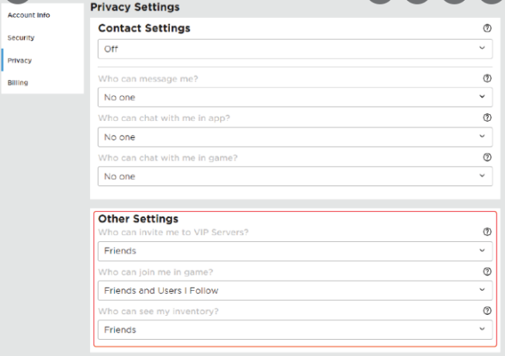
Top tips for parents
Stay engaged | Show an interest and have regular conversations in the games your children are playing. This could be through having a conversation about what they like to play or could be through watching them play the game. You could even have a go at playing the games yourself! If children know you have an interest in the game, they may feel more comfortable talking to you about it or coming to you for help if they need it

Keep personal information private | Help them understand the importance of personal information ● Check that your child understands: - the importance of keeping their personal information safe - that they should speak to an adult straight away if the chat goes from being about the game to meeting up offline, personal information or sending images
Use the safety features | Set up the parental controls that are right for your family. You can also disable chat, set up the Parent PIN and use the Account Restrictions within Roblox. Settings for under 13s: There are additional safety features for under-13s , so it’s worth checking your child’s account is registered with the correct age
As a school, we will continue to develop children’s understanding of how they keep themselves safe while on line and will inform you with any additional information.
Thank you for your continued support

Mrs H Drinkwater
Deputy Headteacher

